mRNA to Amino Acids

Use translation table:

<https://cdn.kastatic.org/ka-perseus-images/f5de6355003ee322782b26404ef0733a1d1a61b0.png>

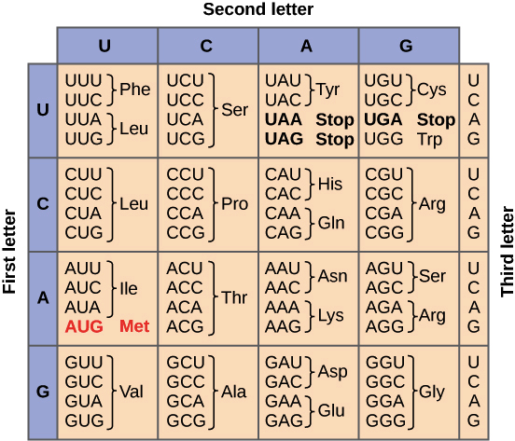

Amino Acids to Single Letters

Use translation table:

| **Abbreviation** | **1 letter abbreviation** | **Amino acid name** |
| --- | --- | --- |
| Ala | A | Alanine |
| Arg | R | Arginine |
| Asn | N | Asparagine |
| Asp | D | Aspartic acid |
| Cys | C | Cysteine |
| Gln | Q | Glutamine |
| Glu | E | Glutamic acid |
| Gly | G | Glycine |
| His | H | Histidine |
| Ile | I | Isoleucine |
| Leu | L | Leucine |
| Lys | K | Lysine |
| Met | M | Methionine |
| Phe | F | Phenylalanine |
| Pro | P | Proline |
| Pyl | O | Pyrrolysine |
| Ser | S | Serine |
| Sec | U | Selenocysteine |
| Thr | T | Threonine |
| Trp | W | Tryptophan |
| Tyr | Y | Tyrosine |
| Val | V | Valine |
| Asx | B | Aspartic acid or Asparagine |
| Glx | Z | Glutamic acid or Glutamine |
| Xaa | X | Any amino acid |
| Xle | J | Leucine or Isoleucine |
| TERM |  | termination codon |